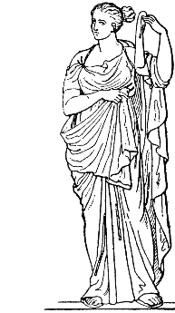
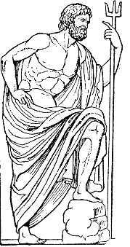
Greek Council
Presents
Greek Week 2018
Greek God and Goddess Competition

Name: ________________________________________________________________________
Last First Middle Initial

Knights Email: ____ ____________________________________________________________

UCFID/PID: _______________________ Phone Number: ________________________

Organization: ______________________ Major/Minor: ______________________________

GPA: ____________ Years involved in Greek Life: ___________________________

List your on-campus leadership roles (Greek, RSO, etc.):

- _____________________________________________________________________

- _____________________________________________________________________

- _____________________________________________________________________

List your on-campus memberships (RSO, President’s Advisory Board, etc.)

- _____________________________________________________________________

- _____________________________________________________________________

- _____________________________________________________________________

**Receipt of application does not guarantee an interview**
FERPA Waiver
I, _______________________________, hereby authorize and consent to the release of my records, which shall include my GPA, major, confirmation of enrollment, contact information, and conduct status to the University of Central Florida for the purpose of verifying my eligibility for the Greek God and Goddess Competition.

Signature______________________________________________Date:__________________
Questionnaire
The following should be completed before turning in this application.

- What is your favorite thing about being a member of this Greek Community?
____________________________________________________________________________________________________________________________________________________________________________________________________________________________________________________________________________________________________________________________________________________________________________________________________________________________________________________________________________________

- What have you accomplished as a member of the Greek Community?
____________________________________________________________________________________________________________________________________________________________________________________________________________________________________________________________________________________________________________________________________________________________________________________________________________________________________________________________________________________

- What does being Greek mean to you?
____________________________________________________________________________________________________________________________________________________________________________________________________________________________________________________________________________________________________________________________________________________________________________________________________________________________________________________________________________________

- What does Greek Unity mean to you?
____________________________________________________________________________________________________________________________________________________________________________________________________________________________________________________________________________________________________________________________________________________________________________________________________________________________________________________________________________________

Questionnaire
The following are a list of questions that may be asked during your interview.

- Why do you want to be Greek God/Goddess?

- What contributions have you made toward creating a better Greek experience here at UCF?

- What is the relevance of Greek Life in today’s society?

- What do you hope to change in Greek Life before you graduate?

- What impact has being Greek made on your life?

- What is your edge over everyone else who applied for this?

- Can you name the four councils that make up UCF Greek Life?

- What can you tell me about each of the four councils that make up UCF Greek Life?

- If you win Greek God/Goddess what will you do with your title?

- What do you think the biggest problem is in Greek Life right now?

- What are your goals for the future?

- How as Greek God/Goddess would you impact the community you represent?

