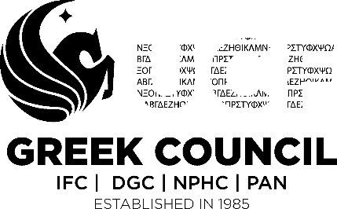

WAY FORWARD 2.0 FORM 3

As the semester is coming to an end this form will serve as a final checkpoint for your organization’s semester progress. This is the last form of the three-part series.

Part I:
- Organization: _____________________________________________________
- Semester: ______________________
- Chapter President: _________________________________________
- Chapter Email: _________________________________________

Part II:
In this part recall your responses from form one and form two.
- Did you uphold your values/principles throughout the semester? If not, what would you change?

- Did your chapter make improvements with any areas of concerns and if so how? If you do not make those changes, what could you have done better?

Part III:
- List your achievements and those you believe helped you in your journey through this semester. (OFSL, national council, other organizations)

- Do you have any suggestions on those you believe could have helped with your journey?

Reminders:
This is a Student Led Development Program facilitated by the Greek Council at UCF and has been adopted with the implementation of 2018 Way Forward 2.0 Program.
This is the final form of this three-part series.

For any question/concerns please contact our vice president of administration:
Kristina Guzman
GCVPAdmin@ucf.edu

X____________________________________________

OFSL Advisor Signature

Date: ________________________________________
*Please print this form to give to your OFSL advisor to sign. Once signed please turn into the Office of Fraternity and Sorority Life via GC VP of Administration Mailbox prior to the deadline. FAILURE TO TURN IN PAPERWORK ON TIME SHALL RESULT IN CHAPTER BEING PLACED ON BAD STANDING UNTIL FORM IS SUBMITTED*

