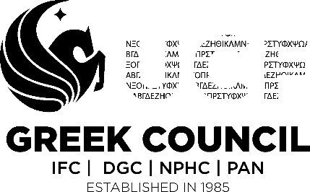 Way Forward 2.0 Form #1

As part of this new initiative all chapters MUST fill out the following form by January 18, 2019 at 5:00pm. This form is part of three form series that will be required by each chapter.
Part I:
- Organization: ____________________________________________
- Semester: Fall/Spring 20__
Part II: Advisor information
Position | Name | Email
OFSL Advisor
UCF Faculty Advisor
Chapter Advisor
Chapter President

Part III: Use S.M.A.R.T goals to complete the following section:
What is a SMART goal? Click here - https://www.mindtools.com/pages/article/smart-goals.htm
- Please list your National/Chapter values/principles:

- Throughout this semester, how do you plan to uphold each individual value/principle? (must have a minimum of one goal per value/principle)

- List a minimum of three areas of improvement outside of your values/principles within your individual chapter.

- What strategies will you be implementing to strengthen each area listed above?

Reminders:
This is a Student Led Development Program facilitated by the Greek Council at UCF and has been adopted with the implementation of 2018 Way Forward 2.0 Program.
There is a second and third part to this form. They will be due:
Form #2 Due Date: Friday, March 8, 2019 at 5:00pm
Form #3 Due Date: Friday, April 19, 2019 at 5:00pm
For any question/concerns please contact our vice president of administration:
Kristina Guzman
GCVPAdmin@ucf.edu

X____________________________________________

OFSL Advisor Signature

Date: ________________________________________
*Please print this form to give to your OFSL advisor to sign. Once signed please turn into the Office of Fraternity and Sorority Life via GC VP of Administration Mailbox prior to the deadline. FAILURE TO TURN IN PAPERWORK ON TIME SHALL RESULT IN CHAPTER BEING PLACED ON BAD STANDING UNTIL FORM IS SUBMITTED*

